Frontend Course Builder
The Frontend course builder is a very unique feature of Tutor LMS that allows instructors to create their courses without being in the backend WordPress panel. This is incredibly useful if you want your platform to have the lowest possible barrier of entry, as teachers don’t have to learn anything about WordPress.
You will, however, require the premium version of Tutor LMS to access the frontend course builder. Once activated, instructors can access this course builder from their frontend dashboard (yourwebsiteURL.com/dashboard) and click on the “Add New Course” button.
If you want to use or are using the Frontend course builder of Tutor LMS pro by navigating from the wp-admin dashboard and edit the course with the Frontend course builder you need to first save the course as a draft from the backend to get the Edit with Frontend option on the top section.
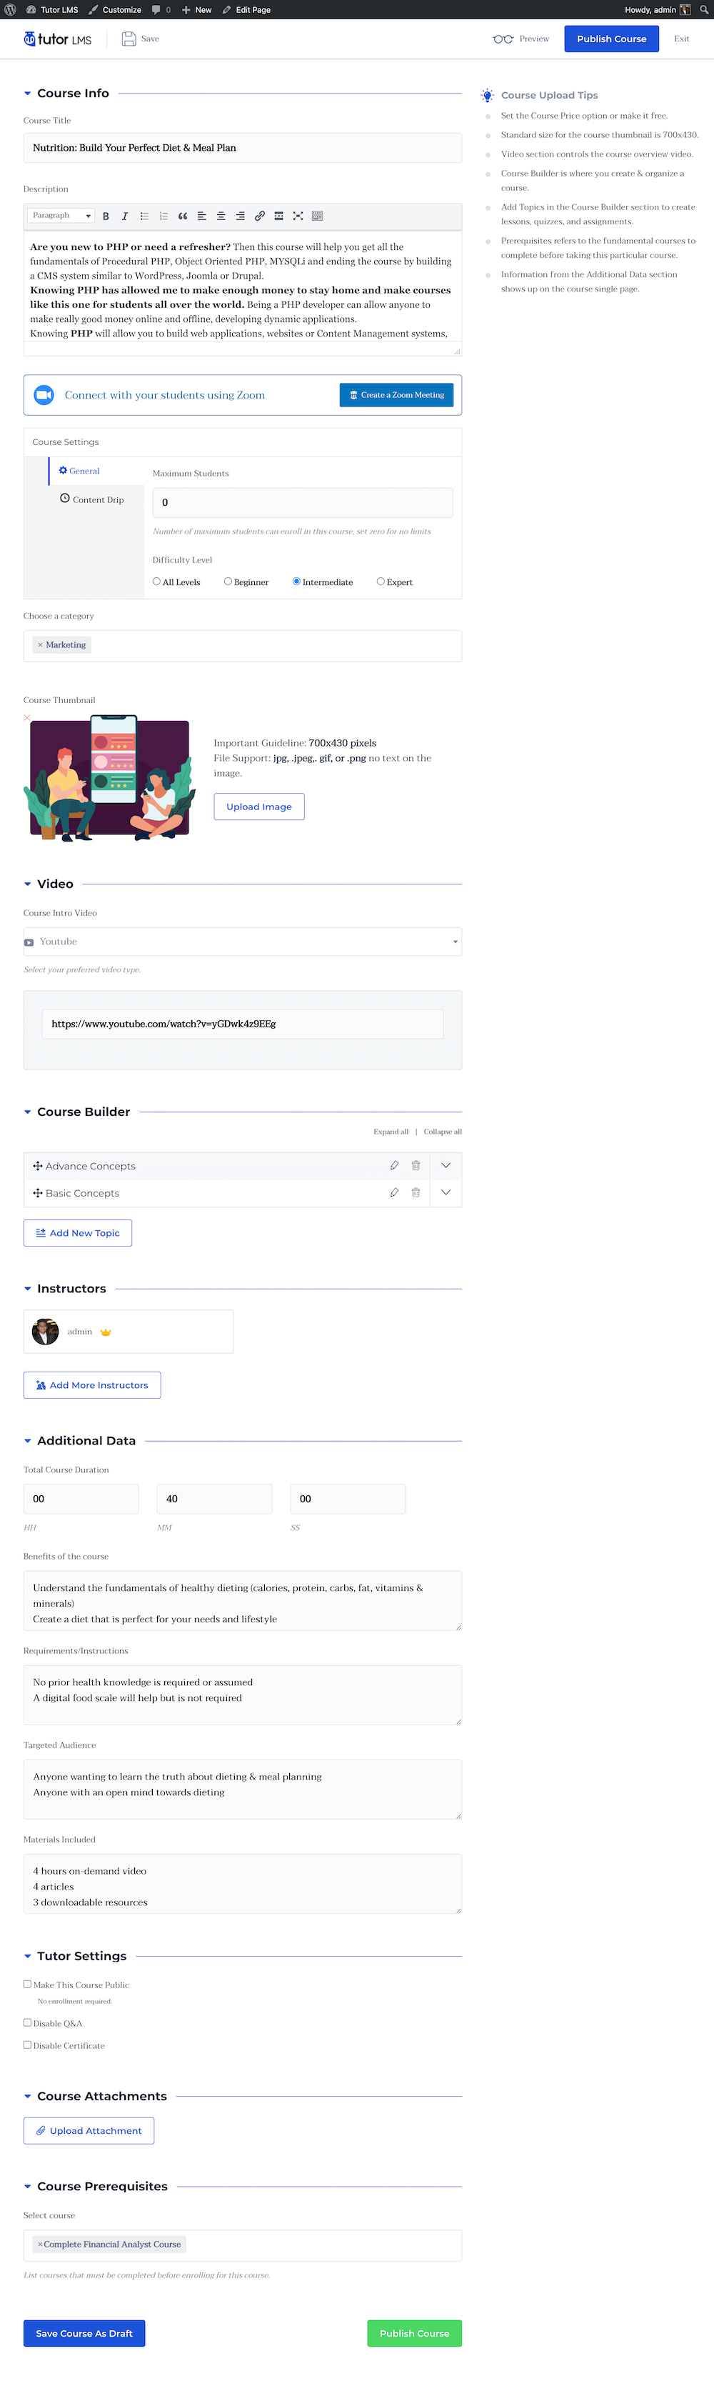

Course Title
This is the main identifier of the course. Make sure to keep this informative and concise.

Description
This is a brief description of the course and its contents. You can describe the topics included in the course, along with additional quizzes, assignments and resources in the course itself.

Course Settings
You can customize a few attributes of the course from these settings, such as course level, and maximum number of students.
You can also set up content drip for this course if you have the Content Drip addon enabled (Pro Feature). To learn about content drip, please visit our documentation on it.

Choose a Category
Select a category for this course. You can add categories from WP Admin > Tutor LMS Pro > Categories.

Course Thumbnail
Give your course an intro image and a visual appeal by adding a thumbnail image. This will show up in all required pages such as course listings and so on. Please make sure to follow the guidelines for the best results.

Course Intro Video
You can give an intro video that will show up on the course overview page. Much like the course description, potential students can get an overview of the course from this. You can select multiple sources such as:
- HTML5
- YouTube,
- Vimeo
- External URL

Course Builder
Course Builder: This is the bread and butter of Tutor LMS. The hierarchy of all the content is crucial for admins and instructors to know properly.
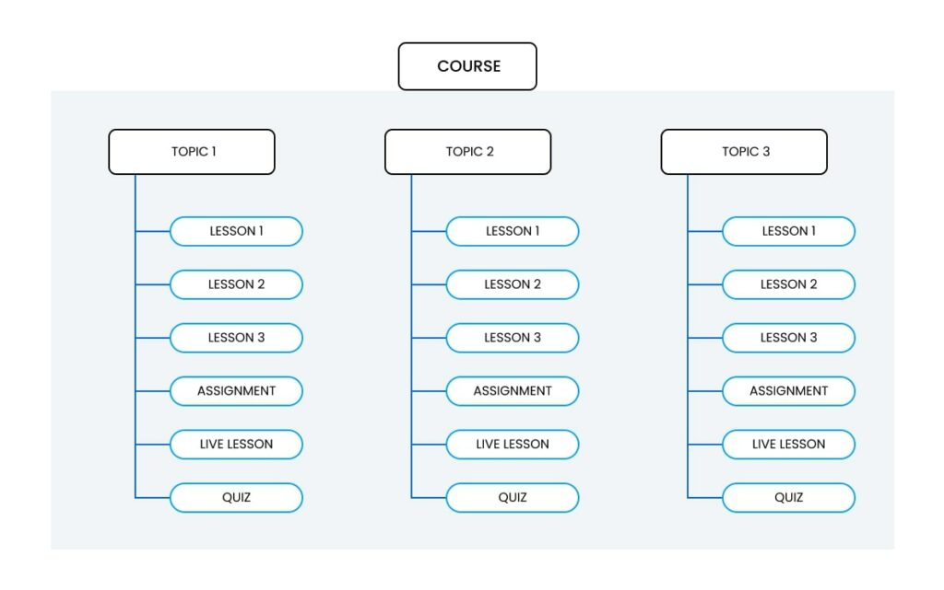
In Tutor LMS, a Course will have Topics, and Topics will have Lessons and Quizzes. There can be multiple quizzes and lessons inside a single topic, but we highly recommend 2-5 lessons and 1 quiz for maximum effectiveness.
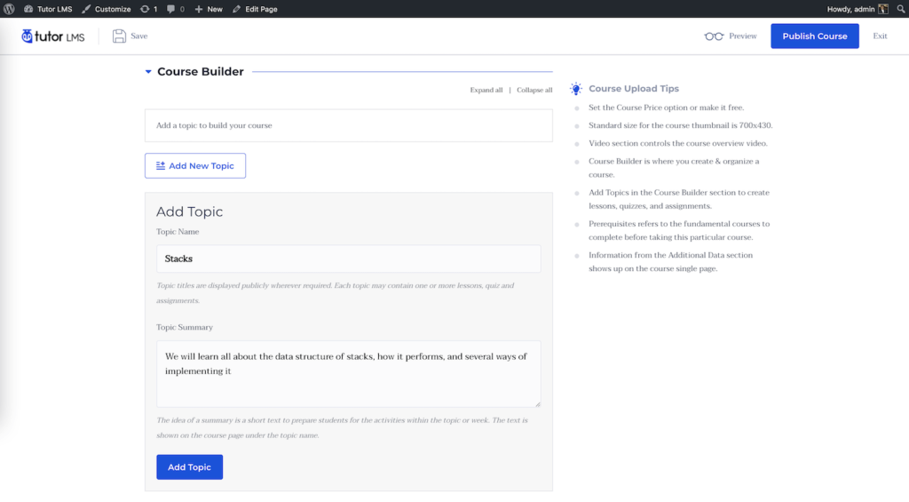
Add New Topic: This button will take you to the topic creation menu where you can give the topic a name and summary. There are tooltips to help you guide through the process. Once you’ve added the required information, you can start adding lessons and quizzes from the buttons below the corresponding topics.
Lesson: Each lesson has a title, description, and optional featured image.
- Video Source: Video source will allow you to add a source for the video lesson. Similar to the intro video, you can add external or internal sources. After adding the video, add the video playback time to the required field.
- Upload Attachments: You can also upload attachments from the courses to supply the necessary materials for this lesson. Once you’re done, you can click on Update Lesson to save and close this tab
Quiz: Quiz building is an extensive feature that deserves its own documentation page. Find the separate documentation page here.
Import Quiz (Pro Feature): You also have the option to export or import quizzes using the free Quiz Import/Export addon available with Tutor LMS Pro. To learn more, please visit the documentation page here.
Assignments (Pro Feature): Assignments are also a Tutor LMS Pro feature that we have covered in a separate documentation page here.
Live Lesson (Pro Feature): You can hold live lessons through Tutor LMS itself. To do so, you will need a Zoom account and you will also have to connect Tutor LMS with Zoom. To learn more about live lessons, please visit a separate documentation on it here.

Instructor
This section allows you to view the instructor names and also allows you to add more instructors to the course. If you have the Multi-Instructor addon (Pro Feature) enabled, you will be able to search for, and add more instructors to the same course. They can then edit, moderate, and add their own content to this course.

Additional Data
This data acts as informative data for potential students while also acting as marketing material for your course.

Course Duration
Specify the overall duration of the course, i.e. how long it will take for a student to complete this course.

Benefits
List the knowledge and skills that students will learn after completing this course. (One per line)

Requirements
Additional requirements or special instructions for the students (One per line).

Target Audience
Specify the target audience that will benefit the most from the course. (One line per target audience)

Materials Included
A list of assets you or the instructors will be providing for the students in this course (One per line)

Tutor Settings
This section contains miscellaneous Tutor LMS settings:
- Make this course public: Making the course public will render all enrollment systems null, and any person visiting this page can access the course without enrolling into the course.
- Disable Q&A: This will disable the course’s built in Q&A forum
- Disable Certificates: This will disable generating certificates for this course. Students will not be able to get certificates for the course.

Course Attachments
Course attachments are resources such as practice files, example files, and other necessary files that you may have used in the course content. Students can download them if they choose to or need to right from here.

Course Prerequisites
Prerequisites are courses that you must finish to get access to this course. For example, if have 2 courses named Basics of Programming Languages and Advanced Programming Languages, then set the basics course as a prerequisite for the advanced course. This will make sure that the students complete the basic course before accessing the advanced course.
This will allow you to create a true and structured learning path for students, with different courses addressing different levels of students.

